Objective of the Lab/Program

Design and Implement the MIPS Register file used for a Single Cycle Micro-architecture in Verilog HDL. The lab’s focus will only be on the Register file component.

Source Code
//Register File Implementation: 32 registers each 32 bits wide, 1 write enable
//1 bit clock, write data 32 bits
module Register_File (A1, A2, A3, WD, WE, Clk, RD1, RD2);

input [4:0]A1, A2, A3;
input [31:0]WD;
input [0:0]Clk, WE;

output reg [31:0] RD1,RD2;

reg[31:0] Registers [0:31];

always @(posedge Clk)
begin
if(WE == 1)
begin
Registers[A3] <= WD; //write data into register A3
end
end

always@(posedge Clk)
begin
RD1 <= Registers [A1];
RD2 <= Registers [A2];
end
endmodule

Screen shot of the simulation (waveforms) showing the results of the Register file operation. Show the results of Read and Write into any two registers.
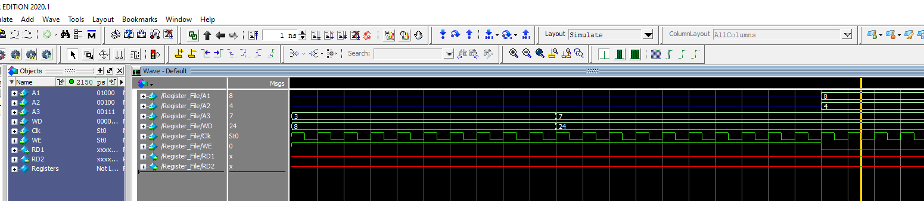

Conclusion and References
After defining all the variables for input and output on the register two conditions used, one checked when the clock was ‘1’ and WE was ‘1’, while the other condition only checked for the clock to be ‘1’. Afterwards the program ran as intended.

